MEMORANDUM OF UNDERSTANDING

between
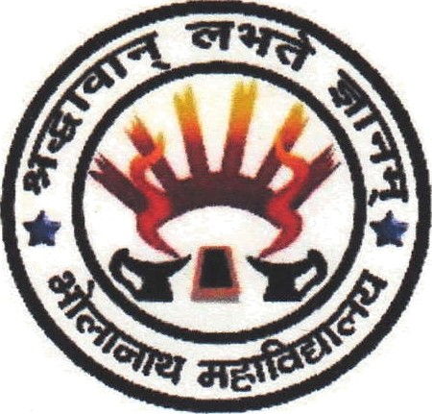
Department of English
B. N. College
College Road, Dhubri -783324 Assam

and

Department of English Language Teaching
Gauhati University
GNB Nagar, Guwahati - 781014

This Memorandum of Understanding (MoU) is effective as of to conduct collaborative academic and research activities by and between:

Department of English B. N. College, Dhubri-783324, Assam
and
Department of English Language Teaching, Gauhati University, Guwahati

The general objective of this Memorandum of Understanding (MoU) is to facilitate the development of collaborative and mutually beneficial programmes which serve to enrich students and faculty members of both the institutions and to promote a cordial academic relationship between the two institutions.

The Department of English B. N. College and Department of English Language Teaching, Gauhati University have agreed that in support of their mutual interests in the field of English language education and research, the institutions will jointly carry out academic activities such as teacher visit programmes and other faculty development activities, organization of workshops for students and teachers, seminars and collaborative small scale research projects from time to time.

The two educational institutions will:
- Cooperate in the exchange of information relating to their activities in teaching and research in fields of mutual interest
- Organize workshops and seminars in the teaching of English
- Train teachers and students to use resources for language learning, including the language laboratory
- Conduct skill enhancement courses and short term programmes

The aim of the Memorandum of Understanding shall be to achieve a broad balance in the respective contributions and benefits of the collaboration, and this shall be subject to periodic review by both the institutions.

The collaborative activities as per this Memorandum of Understanding shall be governed by the rules and regulations of both the institutions.

This agreement will be in force from the date of its signing and shall be valid for a period of 3 (three) years from that date and may be extended by mutual written agreement.

Either institute may terminate the agreement at any time during the agreement period through the provision of three months’ prior written notice to the other institution.

The Department of English Language Teaching, Gauhati University and Department of English B. N. College welcome this Memorandum of Understanding for collaborative academic enterprises and jointly agree to the provisions as set out above.

SIGNATURES:

Signed on behalf of  Department of English,  B.N.College, Dhubri, Assam |  | Signed on behalf of  Dept. of English Language Teaching,  Gauhati University, Assam
(Dr. Dhruba Chakrabortty)  Principal |  | (Dr Hemanta Kumar Nath)  Registrar
Witness No.-1  Name:  Designation:  Signature: |  | Witness No.-2  Name:  Designation:  Signature:

